 ATAR Chemistry Year 11

Gases, Water and Solutions– Test

**Part A: Multiple Choice** – Answer all questions on the grid provided.

1. Which of the following align to the kinetic molecular theory?
   * 1. The volume of gas particles is very large compared to the distance between particles.
     2. The average kinetic energy of particles is proportional to its temperature.
     3. Gas particles move in predictable patterns.
     4. The forces between particles in a gas are negligible.
     5. Gas particles do not collide with each other.
2. i, ii & iii
3. i, iii & v
4. ii only
5. ii & iv
6. Which of the following can change the total volume of a gas?
   1. The number of particles,
   2. The pressure,
   3. The volume
   4. All of the above
7. Which the of the following statements about the group 16 hydrides is false?
   1. Water is the smallest of the group 16 hydride.
   2. Water has the lowest melting point of the group 16 hydrides
   3. Water has the highest boiling point of all group 16 hydrides
   4. Water is the only group 16 hydride to exhibit hydrogen bonding.
8. How many hydrogen bonds can each water molecule make with other water molecules?
   1. 2
   2. 3
   3. 4
   4. 5
9. Which of the following is likely to be most soluble in pentane?
   1. CH4
   2. NH3
   3. HCl
   4. H2O

**6.** Which one of the equations below best represents table sugar, C12H22O11, dissolving in water?

**A** C12H22O11(s) + H2O(l) → C12H23O11(aq) + OH−(aq)

**B** C12H22O11(s) + H2O(l) → C12H21O11−(aq) + H3O+(aq)

**C** C12H22O11(s)  C12H22O11(aq)

**D** C12H22O11(s)  C12H22O11(l)

**7.** Which one of the following describes the types of bonds broken in the solute and formed with water when hydrogen chloride dissolves in water?

|  |  |  |
| --- | --- | --- |
|  | **Bonds broken** | **Bonds formed** |
| **A** | covalent | hydrogen and ion–dipole |
| **B** | dipole-dipole | covalent and dipole–dipole |
| **C** | dipole-dipole | hydrogen and dipole–dipole |
| **D** | covalent | covalent and ion–dipole |

8. Addition of which one of the following substances to an aqueous solution of copper(II) sulfate will notresult in the formation of a precipitate?

A BaCl2(aq)

B NH4Cl(aq)

C Na2CO3(aq)

D K2S(aq)

 ATAR Chemistry – Unit 1 & 2

Gases, Water and Solutions– Test

Name:

Score: /61

*Instructions to students:*

*Complete all questions in this booklet.*

*Scientific calculator & Chemistry Data Book permitted.*

*Time limit – 50 minutes*

Part 1: Multiple Choice answer grid.

For each question shade the box to indicate the answer.

|  |  |  |  |  |
| --- | --- | --- | --- | --- |
| 1. | 🞏 a | ◼ b | 🞏 c | 🞏 d |

Use **only** a blue or black pen to **shade** the boxes.

For example, if b is your answer shade the box to the left of b.

If you make a mistake, place a cross through that square,

**do not erase or use correction fluid**.

|  |  |  |  |  |
| --- | --- | --- | --- | --- |
| 1. | 🞏 a | ◼ b | 🞏 c | ◼ d |

Shade your new answer.

For example, if b is a mistake and d is your correct answer:

In the event that you then change your mind back to your original answer,

you then cross out the second selection and then circle the first choice.

For example, if b was the first choice and d your second, but b is your correct answer:

|  |  |  |  |  |
| --- | --- | --- | --- | --- |
| 1. | 🞏 a | ◼ b | 🞏 c | ◼ d |

|  |  |  |  |  |  |  |  |  |  |  |
| --- | --- | --- | --- | --- | --- | --- | --- | --- | --- | --- |
| 1 | 🞏 a | 🞏 b | 🞏 c | 🞏 d |  | 5 | 🞏 a | 🞏 b | 🞏 c | 🞏 d |
| 2 | 🞏 a | 🞏 b | 🞏 c | 🞏 d |  | 6 | 🞏 a | 🞏 b | 🞏 c | 🞏 d |
| 3 | 🞏 a | 🞏 b | 🞏 c | 🞏 d |  | 7 | 🞏 a | 🞏 b | 🞏 c | 🞏 d |
| 4 | 🞏 a | 🞏 b | 🞏 c | 🞏 d |  | 8 | 🞏 a | 🞏 b | 🞏 c | 🞏 d |
|  |  |  |  |  |  |  |  |  |  |  |
|  |  |  |  |  |  |  |  |  |  |  |

**/8**

**Part 2: Short answer section – answer in the space provided. Total : 53 marks**

**Question 1 (12 marks)**

Phosgene [COCl2] is a major industrial chemical used to make plastics and pesticides. Phosgene gas may appear colourless or as a white to pale yellow cloud. At low concentrations, it has a pleasant odour of newly mown hay or green corn, but its odour may not be noticed by all people exposed.

1. Draw an electron dot diagram to represent a molecule of phosgene. [2]

,

1. State the shape of molecule ______________________________ [1]
2. Describe and explain the strongest intermolecular forces between molecules of phosgene.[2]

…………………………………………………………………………………………………………………………………………..

…………………………………………………………………………………………………………………………………………….

…………………………………………………………………………………………………………………………………………..

…………………………………………………………………………………………………………………………………………….

1. Predict and explain the solubility of phosgene in (i) water and (ii) liquid chloroform (CHCl3) [4]
2. water

……………………………………………………………………………………………………………………………………….

………………………………………………………………………………………………………………………………………………….

…………………………………………………………………………………………………………………………………………………

1. (ii) liquid chloroform (CHCl3) ………………………………………………………………………………………………………………………………….

………………………………………………………………………………………………………………………………………………….

…………………………………………………………………………………………………………………………………………………

Phosgene gas is produced from the reaction of carbon monoxide gas and chlorine gas as shown in the reaction below:

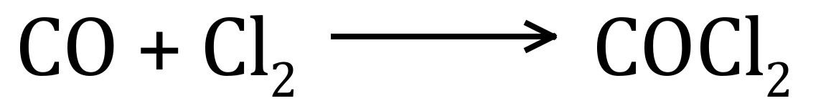

1. Determine the mass of chlorine gas required to produce 100 L of phosgene gas at STP? [3]

**Question 2 [7 marks]**

Butane reacts with oxygen gas to produce carbon dioxide and water vapour.



If 100 mL of CO2 is produced at a temperature of 50°C and pressure 150kPa

1. Calculate the volume of butane consumed? [2]

1. Calculate the mass of water vapour produced. [5]

**Question 3 [ 9 marks]**

Refer to the solubility curves shown below to answer the questions that follow.

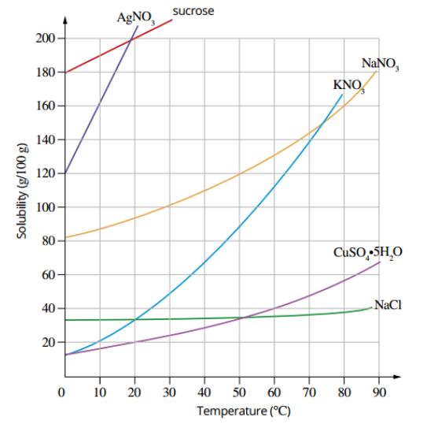

a) Classify the following solutions as unsaturated, saturated, or super saturated: [3]

* + 1. 10g of NaCl in 50g of H2O at 30°C …………………………..
    2. 40g of NaNO3 in 25g of H2O at 80°C ………………………….
    3. 300g of KNO3 in 150g of H2O at 50°C ………………………………

1. 300g of KNO3 is dissolved in 400g of water at a temperature of 70°C before being cooled to a temperature of 20°C. estimate the mass of KNO3 crystals that will form. [3]
2. 20g of NaNO3 is dissolved in 25g of water at 10°C. what extra mass of NaNO3 could be dissolved if the temperature is raised to 50°C? [3]

Question 4 (7 marks)

Small amounts of solid magnesium chloride and liquid ethanol are dissolved in separate beakers of water.

a i Write an ionic equation for the dissolving process of magnesium chloride in water. [1]

______________________________________________________________________

______________________________________________________________________

ii What attractive forces need to break in the solid magnesium chloride for it to dissolve?

(1 )

______________________________________________________________________

iii What attractive forces are formed when magnesium chloride dissolves in water?

(1)

______________________________________________________________________

b i Write an equation for the dissolving process of ethanol, C2H5OH, in water. (1 )

______________________________________________________________________

______________________________________________________________________

ii What attractive forces need to break in the liquid ethanol for it to dissolve? (2 )

______________________________________________________________________

______________________________________________________________________

iii What attractive forces are formed when ethanol dissolves in water? (1 )

______________________________________________________________________

Question 5 (4 marks)

a Write full molecular equations and ionic equations for reactions between each of the following. Include state symbols.

i solutions of barium nitrate and potassium sulfate (2 mark)

______________________________________________________________________

______________________________________________________________________

i solutions of sodium carbonate and barium hydroxide (2 mark)

______________________________________________________________________

______________________________________________________________________

Question 6 (5 marks)

12.75 mL of 0.188 mol L−1 sodium hydroxide solution is needed to precipitate all the lead from 25.0 mL solution of lead(II) nitrate. The balanced equation for the reaction is shown below.

2NaOH(aq) + Pb(NO3)2(aq) → 2NaNO3(aq) + Pb(OH)2(s)

1. Calculate the mass of precipitate. [3]

____________________________________________________________________________

____________________________________________________________________________

____________________________________________________________________________

____________________________________________________________________________

____________________________________________________________________________

____________________________________________________________________________

1. Calculate the concentration of Pb2+ ions in Pb(NO3)2 [2]

____________________________________________________________________________

____________________________________________________________________________

____________________________________________________________________________

____________________________________________________________________________

____________________________________________________________________________

____________________________________________________________________________

**Question 7 [ 2 marks]**

A 200 mL solution of potassium sulphate has a concentration of 0.050mol L-1. Calculate the volume of water that needs to be added to make a concentration of 0.0215mol L-1.

____________________________________________________________________________

____________________________________________________________________________

____________________________________________________________________________

____________________________________________________________________________

____________________________________________________________________________

**Question 8 [6 marks]**

1. Carbon dioxide in a 30 L container exerts a pressure of 150kPa at 25°C.

If the volume of the container is increased to 60L determine the expected pressure? [1]

……………………………………………………………………………….

1. A separate 30L container contains Nitrogen gas at 150kPa and 25°C. Circle the correct response (3)

The mass of gas in the two containers will be the same **True / False**

The number of molecules will be the same **True/False**

The number of atoms of nitrogen will be **greater/ the same /less than** the number of atoms of carbon

1. If the temperature of the 30L CO2 container is increased to 100°C determine the pressure increase. (2)

____________________________________________________________________________

____________________________________________________________________________

____________________________________________________________________________

____________________________________________________________________________

End of Test